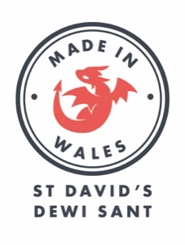
APPLICATION QUESTIONNAIRE

Please download this form before filling it in – there is no option to submit the form online. It needs to be saved and emailed to us!

Applicant details
Applicant name
Email address
Telephone number
Business / company name
Is this a limited company? (Y/N)
Company number, if applicable

Company information
We would love to get a better understanding of your brand as part of the judging process. Please include any information about your brand identity, values, and target audience that you think is relevant.

Products or service offered
Website:
Trading since (date)
Background information and trading history (100 words max)

What do you think makes your business special? (100 words max)
Annual turnover 2019-20 (if applicable)
Annual turnover 2018-19 (if applicable)
Do you have a business plan or a vision of how you would like to grow your business over the next 5 years (100 words max)
Are you attaching images of products or current shops/displays etc (Y/N)

Pop up shop experience

How will you transform the space into an engaging store and offer a great experience for customers (100 words max)
What element to the visual display (fixtures/ props/ themes) would you look to introduce to stand out and attract customers? (100 words max)
What are your marketing plans to raise awareness of the shop and drive footfall from opening day (100 words max)
Will you be ready to trade at St David’s from 1st October
Can you confirm that you have read and understand the terms & conditions of entry? (Y/N)

Completed application forms must be sent to Madein@landsec.com by 11.59pm on Monday 17th August at the latest.

By emailing your entry and providing your contact details, you consent to being contacted by the organisers of this competition.

